Section 3: Meteorological Data Forecasting
Data Download URL：https://cds.climate.copernicus.eu/datasets/derived-era5-single-levels-daily-statistics?tab=download

Select all options as shown in the figure below and complete the data download

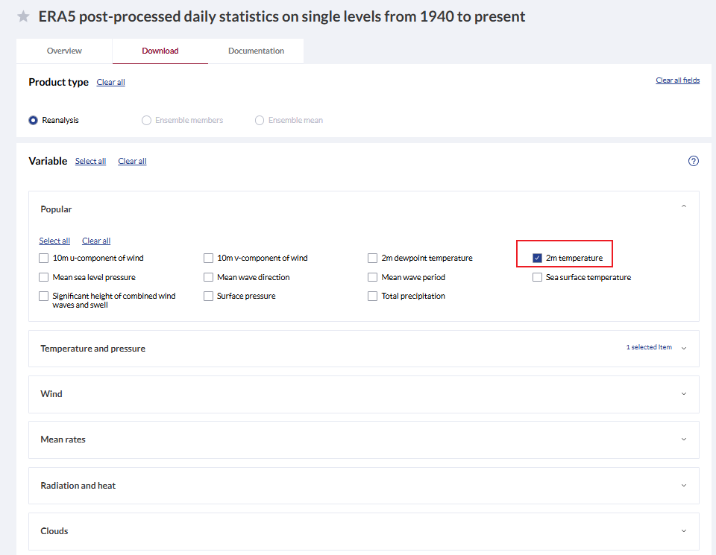
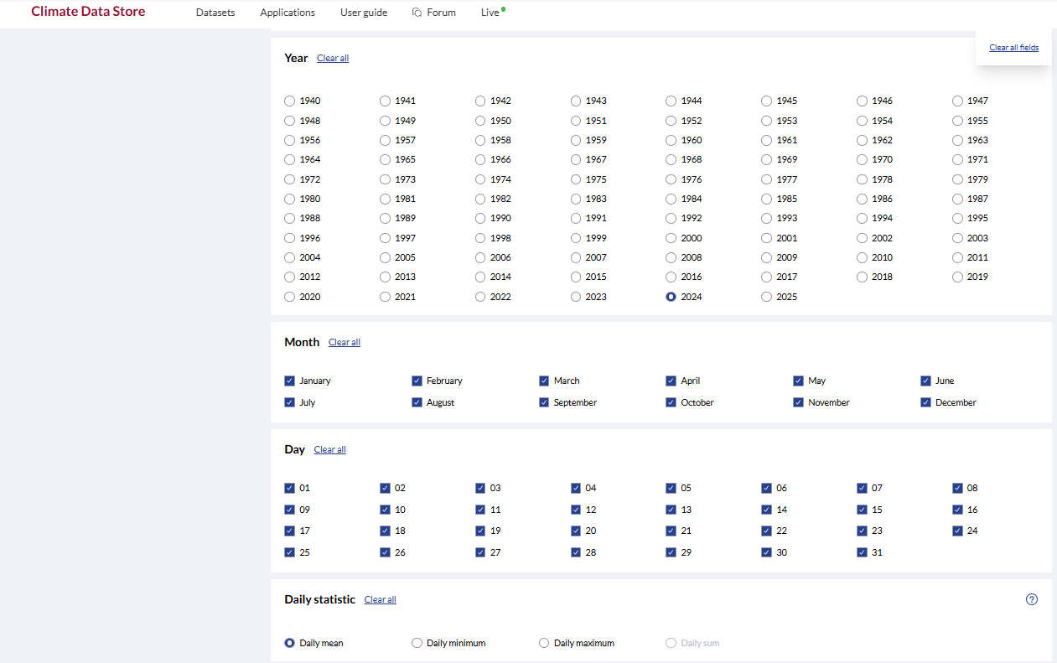
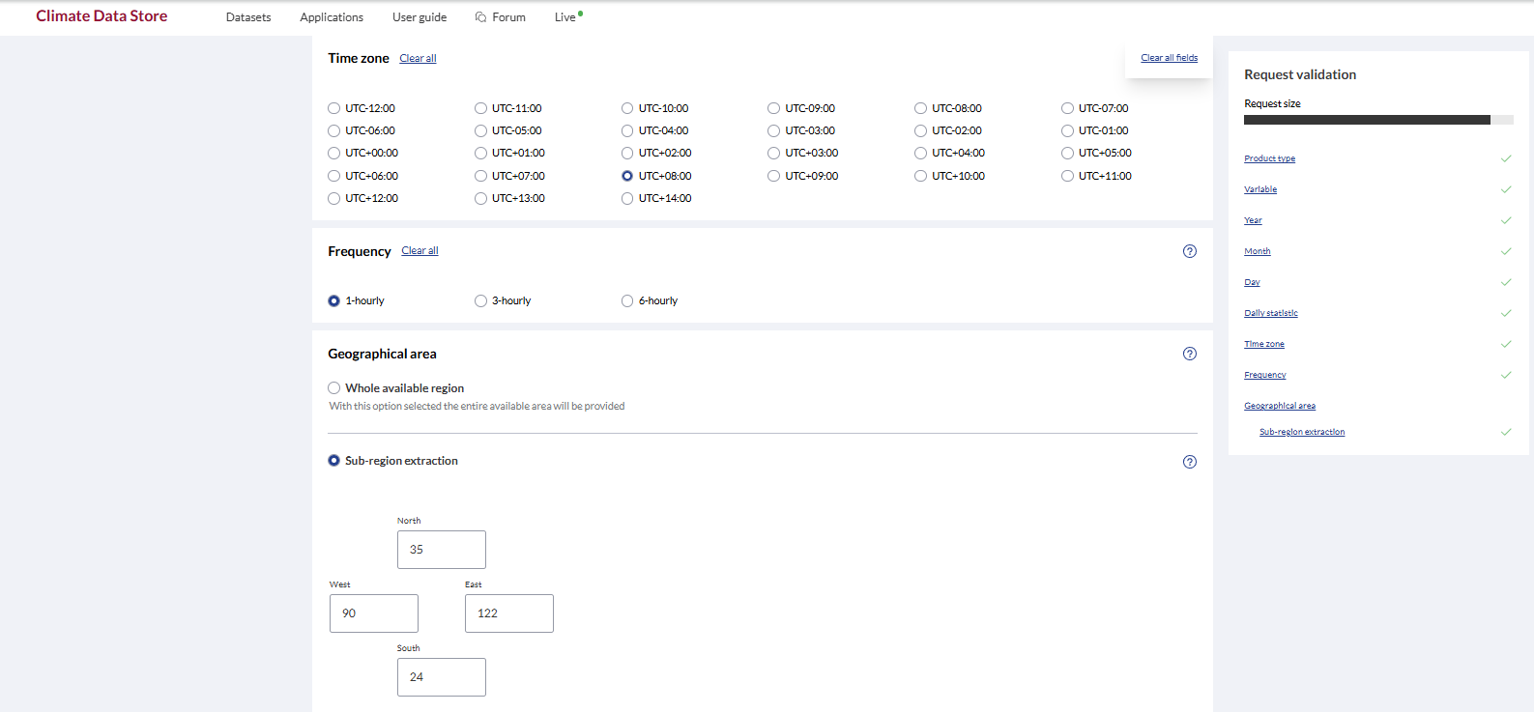
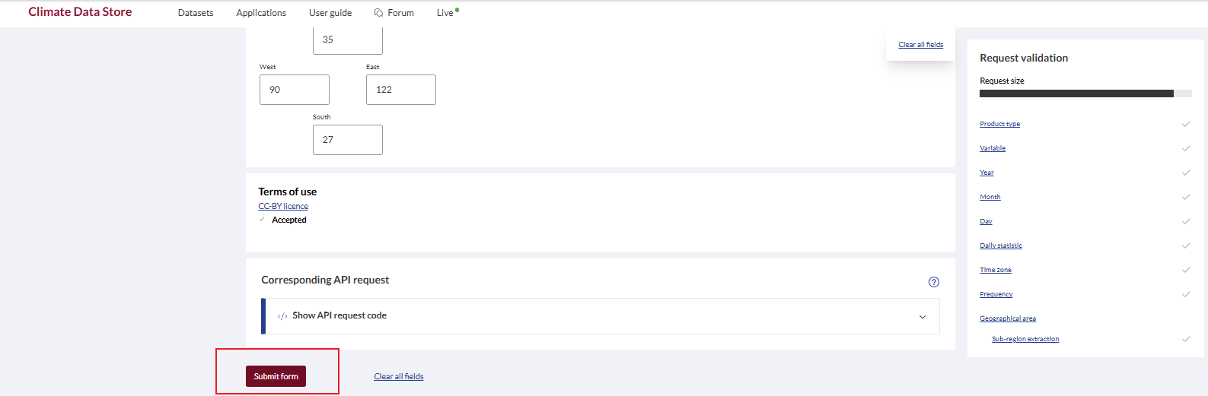
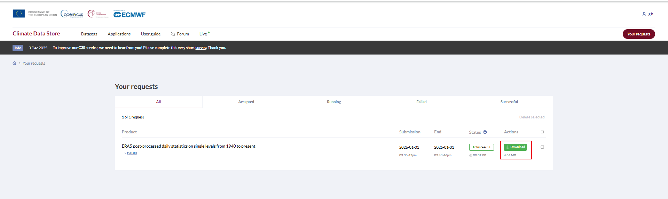
After completing the data download, ensure that your Python environment is properly configured. Then, run the following code, remembering to modify the file path to match the path on your own computer.

Guide to Meteorological Data Forecasting with LSTM
This document provides a comprehensive introduction to the Python code designed for predicting future meteorological temperatures using a Long Short-Term Memory (LSTM) neural network. The goal is to teach students how to load, preprocess, model, and forecast time series data.
I. Purpose
The primary objective of this code is to demonstrate a complete workflow for time series forecasting using deep learning. Specifically, it uses historical daily average temperature data (from a NetCDF file) to train an LSTM model. The trained model is then used to:

Evaluate its performance by predicting known future values (on a test set).
Generate a 30-day rolling forecast to predict temperatures for days beyond the original dataset.

This project serves as an excellent example of how machine learning can be applied to predict future events based on past observations.
II. Core Concept: Time Series Forecasting
Time series forecasting is the task of predicting future values based on previously observed values. The fundamental idea is that past patterns and trends in the data can help us anticipate what will happen next.
In this code, we use a sliding window approach:

We look back at the average temperature over a fixed number of days (e.g., 14 days).
We use these 14 days of data to predict the average temperature of the next day.

The LSTM (Long Short-Term Memory) model is particularly well-suited for this task because it is designed to learn from sequences of data and can remember information over long periods, making it ideal for capturing complex patterns in time series.
III. Key Libraries Used
The code leverages several powerful Python libraries for data science and machine learning:

xarray: Used for loading and manipulating multi-dimensional scientific data, such as the NetCDF (.nc) file format commonly used in meteorology.
numpy: The fundamental package for scientific computing in Python, used here for numerical operations and array manipulations.
torch (PyTorch): A popular deep learning framework used to define, train, and run the LSTM neural network model.
sklearn (Scikit-learn): A machine learning library used for data preprocessing (MinMaxScaler) and model evaluation (calculating MAE, RMSE, R² scores).
matplotlib.pyplot: A plotting library used to visualize the actual temperatures, model predictions, and future forecasts.

IV. Step-by-Step Code Walkthrough
The code is structured into logical sections to guide you through the entire process.
1. Data Loading and Preprocessing

load_data(file_path): This function reads the NetCDF file. It extracts the 't2m' (2-meter temperature) variable, which is a 3D array (time, latitude, longitude). To simplify the problem into a univariate time series, it calculates the spatial average (mean over latitude and longitude) for each day, resulting in a 1D array of daily average temperatures.
create_sequences(data, seq_length): This is a crucial function. It transforms the 1D temperature array into input-output pairs for the model. For each day i, it creates an input sequence X (the temperatures of the previous seq_length days) and a corresponding output y (the temperature of the next day).

2. LSTM Model Definition

class LSTMModel(nn.Module): This class defines the architecture of the LSTM model using PyTorch.
It consists of an LSTM layer that processes the input sequences and learns temporal patterns.
The output of the LSTM layer is then passed through a fully connected (Linear) layer to produce a single predicted value (the next day's temperature).

3. Parameter Configuration

This section sets up all the hyperparameters and configurations needed to run the model.
file_path: The location of your data file. You must change this to match the path on your own computer.
seq_length: The number of past days (time steps) used to make a prediction (e.g., 14).
train_split: The proportion of data used for training the model (e.g., 0.8 means 80% for training, 20% for testing).
epochs: The number of times the entire training dataset is passed through the model.
device: Automatically selects the GPU (cuda) if available for faster computation, otherwise uses the CPU.
Data Preparation: The raw data is normalized using MinMaxScaler to scale all values between 0 and 1. This is a common practice that helps the neural network train more efficiently. The data is then split into training and testing sets and converted into PyTorch tensors.

4. Train the Model

This section contains the training loop. The model is trained to minimize the Mean Squared Error (MSE) between its predictions and the actual temperatures in the training set. The Adam optimizer is used to update the model's weights.

5. Model Evaluation (Test Set Prediction)

After training, the model is evaluated on the unseen test set.
Predictions are made, and then inverse scaled to convert them back from the 0-1 range to the original temperature scale (in Kelvin).
Three key metrics are calculated to assess performance:
MAE (Mean Absolute Error): The average absolute difference between predictions and actual values.
RMSE (Root Mean Squared Error): The square root of the average squared difference, which penalizes larger errors more heavily.
R² (Coefficient of Determination): A score between 0 and 1 indicating how well the model's predictions fit the actual data (1 is a perfect fit).

6. Rolling Forecast for Next 30 Days

This is where the model is used for true prediction of future, unseen data.
Starting with the last seq_length days from the dataset, the model predicts the next day's temperature.
This new prediction is then added to the end of the input window, and the oldest day is dropped.
This process repeats for 30 steps, effectively "rolling" the prediction window forward in time to generate a 30-day forecast.

7. Visualization

Finally, the results are plotted to provide a clear visual comparison:
The actual historical temperatures (black line).
The model's predictions on the test set (blue line), showing how well it performs on known data.
The 30-day rolling forecast (red dashed line), showing the predicted future temperatures.

V. How to Run the Code

Install Required Libraries: Ensure you have Python installed, then install the necessary packages using pip:
bash

运行

pip install xarray numpy torch scikit-learn matplotlib netCDF4

Prepare Your Data: Download the NetCDF data file and place it in a known location on your computer.
Update the File Path: Open the Python script and find the line file_path = '...'. Change the path inside the quotes to match the location of your data file.
Run the Script: Execute the Python file. You will see training progress in the console, followed by the evaluation metrics. Finally, a plot window will appear showing the results.

VI. Expected Output

Console Output: You will see the loss decreasing during training and the final evaluation metrics (MAE, RMSE, R²) printed to the screen.
Plot: A graph will display the historical temperature data, the model's test predictions, and the 30-day future forecast, allowing you to visually inspect the model's performance and the predicted trend.

This guide provides a solid foundation for understanding and using the code to perform time series forecasting with LSTMs.

import xarray as xr
import numpy as np
import pandas as pd
import torch
import torch.nn as nn
from sklearn.preprocessing import MinMaxScaler
from sklearn.metrics import mean_absolute_error, mean_squared_error, r2_score
import matplotlib.pyplot as plt

# ==========================================
# 1. Data Loading and Preprocessing (Unchanged)
# ==========================================
def load_data(file_path):
ds = xr.open_dataset(file_path)
# Extract t2m (time=366, lat=45, lon=129)
# Average over spatial dimensions to get daily mean temperature series
data = ds['t2m'].mean(dim=['latitude', 'longitude']).values
data = data[~np.isnan(data)].reshape(-1, 1)
return data

def create_sequences(data, seq_length):
xs, ys = [], []
for i in range(len(data) - seq_length):
x = data[i:(i + seq_length)]
y = data[i + seq_length]
xs.append(x)
ys.append(y)
return np.array(xs), np.array(ys)

# ==========================================
# 2. LSTM Model Definition
# ==========================================
class LSTMModel(nn.Module):
def __init__(self, input_size=1, hidden_size=128, num_layers=2):
super(LSTMModel, self).__init__()
self.lstm = nn.LSTM(input_size, hidden_size, num_layers, batch_first=True, dropout=0.2)
self.linear = nn.Linear(hidden_size, 1)

def forward(self, x):
out, _ = self.lstm(x)
out = self.linear(out[:, -1, :])
return out

# ==========================================
# 3. Parameter Configuration
# ==========================================
file_path = '9656711b4365b7d4f419fc7cbf0d25b7.nc' # Please ensure the path is correct
seq_length = 14 # Use past 14 days to predict the future
train_split = 0.8 # 80% for training
epochs = 150
device = torch.device('cuda' if torch.cuda.is_available() else 'cpu')

# Data preparation
raw_data = load_data(file_path)
scaler = MinMaxScaler()
scaled_data = scaler.fit_transform(raw_data)

X, y = create_sequences(scaled_data, seq_length)
train_size = int(len(X) * train_split)

X_train, X_test = X[:train_size], X[train_size:]
y_train, y_test = y[:train_size], y[train_size:]

# Convert to tensors
X_train = torch.FloatTensor(X_train).to(device)
y_train = torch.FloatTensor(y_train).to(device)
X_test = torch.FloatTensor(X_test).to(device)

# ==========================================
# 4. Train the Model
# ==========================================
model = LSTMModel().to(device)
criterion = nn.MSELoss()
optimizer = torch.optim.Adam(model.parameters(), lr=0.001)

print("Starting training...")
for epoch in range(epochs):
model.train()
optimizer.zero_grad()
y_pred = model(X_train)
loss = criterion(y_pred, y_train)
loss.backward()
optimizer.step()
if (epoch+1) % 30 == 0:
print(f'Epoch [{epoch+1}/{epochs}], Loss: {loss.item():.6f}')

# ==========================================
# 5. Model Evaluation (Test Set Prediction)
# ==========================================
model.eval()
with torch.no_grad():
# Make one-step predictions on the test set
test_preds = model(X_test).cpu().numpy()
# Inverse scaling
test_preds_rescaled = scaler.inverse_transform(test_preds)
y_test_rescaled = scaler.inverse_transform(y_test)

# Calculate metrics
mae = mean_absolute_error(y_test_rescaled, test_preds_rescaled)
rmse = np.sqrt(mean_squared_error(y_test_rescaled, test_preds_rescaled))
r2 = r2_score(y_test_rescaled, test_preds_rescaled)

print("\n" + "="*30)
print("Model Evaluation Metrics (Test Set):")
print(f"MAE (Mean Absolute Error): {mae:.4f} K")
print(f"RMSE (Root Mean Squared Error): {rmse:.4f} K")
print(f"R² (Coefficient of Determination): {r2:.4f}")
print("="*30)

# ==========================================
# 6. Rolling Forecast for Next 30 Days
# ==========================================
forecast_steps = 30
last_window = torch.FloatTensor(scaled_data[-seq_length:]).view(1, seq_length, 1).to(device)
rolling_preds = []

current_window = last_window
with torch.no_grad():
for _ in range(forecast_steps):
pred = model(current_window)
rolling_preds.append(pred.item())
# Update the sliding window
pred_tensor = pred.view(1, 1, 1)
current_window = torch.cat((current_window[:, 1:, :], pred_tensor), dim=1)

rolling_preds_rescaled = scaler.inverse_transform(np.array(rolling_preds).reshape(-1, 1))

# ==========================================
# 7. Visualization
# ==========================================
plt.figure(figsize=(14, 7))

# 1. Plot actual values for training + test sets
plt.plot(range(len(raw_data)), raw_data, label='Actual Temperature', color='black', alpha=0.3)

# 2. Plot test set prediction comparison
test_start_idx = train_size + seq_length
plt.plot(range(test_start_idx, test_start_idx + len(test_preds_rescaled)),
test_preds_rescaled, label='Test Set Prediction (One-step)', color='blue')

# 3. Plot future rolling forecast
plt.plot(range(len(raw_data), len(raw_data) + forecast_steps),
rolling_preds_rescaled, label='Future Rolling Forecast (30 days)', color='red', linestyle='--')

plt.axvline(x=test_start_idx, color='gray', linestyle='--', label='Test Split Start')
plt.title(f'T2M Prediction (R²: {r2:.3f})')
plt.xlabel('Days (2024)')
plt.ylabel('Temperature (K)')
plt.legend()
plt.grid(True, alpha=0.3)
plt.show()

Guide to "Face-to-Point" Meteorological Data Prediction with CNN
This document provides a comprehensive introduction to the second Python code script. It aims to predict future regional average temperatures using a Convolutional Neural Network (CNN). Unlike the previous LSTM model, this model leverages spatial information—i.e., 2D temperature field distributions over consecutive days—to make predictions.
I. Purpose
The core objective of this code is to demonstrate a face-to-point prediction task. Specifically, it uses historical 2D temperature field data (extracted from NetCDF files) over consecutive days as input to train a CNN model. The trained model learns to extract key spatial features from these weather patterns and outputs a single predicted value: the regional average temperature for a future day.
This project illustrates how deep learning can capture and utilize spatial relationships in data, a capability critical for fields like meteorology, remote sensing, and geosciences.
II. Core Concepts: Face-to-Point Prediction & CNN
1. Face-to-Point Prediction

"Face": Refers to the input data, which is a 2D or 3D spatial grid. In this case, it represents the daily temperature distribution across latitude and longitude coordinates—essentially a "weather map" for each day.
"Point": Refers to the output, which is a single scalar value. Here, it is the average temperature of the entire region on the target day.

This approach outperforms single-point time series methods by incorporating rich spatial patterns, such as the movement of high-temperature centers, the gradient of temperature changes, and the interaction between warm and cold air masses.
2. Convolutional Neural Network (CNN)
CNNs are a class of neural networks specifically designed for processing grid-structured data (e.g., images, spatial grids). Their key advantages for this task include:

Convolutional Layers (Conv2d): Use "kernels" to slide over the input data and automatically extract local spatial features (e.g., temperature gradients, high/low-temperature clusters).
Pooling Layers (MaxPool2d): Reduce the dimensionality of feature maps, retain the most salient features, and decrease computational complexity.
Adaptive Pooling (AdaptiveAvgPool2d): Automatically resizes feature maps to a fixed size (1×1 in this code) regardless of input dimensions, simplifying the transition from spatial features to fully connected layers.

For these reasons, CNNs are ideal for learning complex spatial patterns from 2D temperature fields.
III. Key Libraries & Data Format

xarray, numpy, torch, sklearn, matplotlib.pyplot: These libraries serve the same purposes as in the LSTM example—data loading, numerical computation, model construction, data preprocessing, and result visualization.
torch.utils.data.DataLoader: This library is critical for this project. Given that the input data is 3D (sequence length × latitude × longitude), loading all data at once may consume excessive memory. DataLoader enables batch loading of data into the model, significantly improving training efficiency and memory utilization.

IV. Step-by-Step Code Walkthrough
1. Data Preparation (Face-to-Point)

load_spatial_data(file_path, seq_length):
Data Loading: Reads the NetCDF file and extracts the t2m variable, generating a 3D array with dimensions (time × latitude × longitude).
Data Cleaning: Detects and fills NaN (missing values) to ensure data integrity.
Data Normalization: Scales all temperature values to the range [0, 1] using MinMaxScaler, which is essential for stable neural network training.
Sequence Construction: This is the core of the face-to-point transformation. It iterates over the time series and generates input-output pairs for each time step:
An input X: A 3D block containing the complete temperature field data for the past seq_length days, with dimensions (seq_length, lat, lon).
A label Y: A scalar value representing the average temperature of the entire region on day i + seq_length.

2. Define CNN Model (Face-to-Point)

class TemperatureCNN(nn.Module):
Convolutional Layers (self.conv_layer):
The model takes a 3D data block as input. in_channels is set to seq_length, treating the temperature fields of consecutive days as a multi-channel image.
Stacking convolutional layers (Conv2d), activation functions (ReLU), and pooling layers (MaxPool2d), the network gradually extracts increasingly complex spatial features.
The final layer AdaptiveAvgPool2d((1, 1)) is a sophisticated design. It automatically pools the feature maps output by previous convolutional layers into a 1×1 feature map, regardless of their original size. This makes the model insensitive to input image dimensions and condenses all spatial information into the channel dimension.
Fully Connected Layers (self.fc_layer):
x.view(x.size(0), -1) "flattens" the output of the convolutional layers (shape: [batch_size, 128, 1, 1]) into a 1D vector (shape: [batch_size, 128]).
This vector is then fed into a simple fully connected neural network, which outputs a single predicted value.

3. Training and Evaluation

Configuration & Data Loading: Sets hyperparameters such as file path, sequence length, and batch size. Loads data and splits it into training and test sets.
DataLoader Creation: DataLoader packages training data into batches and shuffles the data at the start of each epoch, which helps the model generalize better.
Model Initialization: Creates an instance of TemperatureCNN and defines the loss function (MSE) and optimizer (Adam).
Training Loop: Follows a standard PyTorch training workflow. Iterates over batches of data, performs forward propagation, calculates loss, runs backpropagation, and updates model parameters.

4. Evaluate Results
Evaluates model performance on the test set. Note that since both predictions and ground truth values are normalized, they must be inversely scaled back to the original temperature unit (Kelvin, K) using scaler.inverse_transform before calculating evaluation metrics (MAE, RMSE, R²).
5. Visualization
Plots the actual average temperatures and the model's predicted average temperatures on the test set in a single chart, providing an intuitive comparison of the model's prediction accuracy.
V. How to Run the Code

Install Required Libraries: If not already installed, run the following command:
bash

运行

pip install xarray numpy torch scikit-learn matplotlib netCDF4

Prepare Data: Ensure the NetCDF data file is in the same directory as the Python script, or modify the file_path variable in the code to the absolute path of the file.
Run the Script: Execute the Python file directly. The program will start training, print evaluation metrics upon completion, and display the visualization chart.

VI. Expected Outputs

Console Output: You will see the training progress of the model, followed by the final MAE, RMSE, and R² scores on the test set.
Visualization Chart: A plot containing two lines: one representing the actual average temperatures on the test set, and the other representing the predicted average temperatures from the model. The degree of overlap between the two lines provides a visual indication of the model's prediction accuracy.
How to Choose the Right Model

Use the CNN model if you believe that spatial distribution patterns (e.g., the movement of weather systems) are the key drivers of future temperatures.
Use the LSTM model if historical temperature trends are the dominant factor.
In practical applications, a hybrid model (e.g., CNN-LSTM) is often used to leverage both spatial and temporal information simultaneously, achieving even higher prediction accuracy.
Final Notes
Ensure the file_path variable is updated to match the actual location of your NetCDF file on your computer.
Adjust hyperparameters (e.g., seq_len, batch_size, epochs) based on your specific dataset size and computational resources for optimal performance.

import xarray as xr
import numpy as np
import torch
import torch.nn as nn
import torch.optim as optim
from torch.utils.data import DataLoader, TensorDataset
from sklearn.preprocessing import MinMaxScaler
from sklearn.metrics import mean_absolute_error, mean_squared_error, r2_score
import matplotlib.pyplot as plt

# ==========================================
# 1. Data Preparation (Face-to-Point)
# ==========================================
def load_spatial_data(file_path, seq_length=7):
ds = xr.open_dataset(file_path)
# Extract t2m: (366, 45, 129)
data = ds['t2m'].values

# Fill NaN values (using mean imputation)
if np.isnan(data).any():
data = np.nan_to_num(data, nan=np.nanmean(data))

# 2. Construct sequences
# X: 2D images of the past seq_length days (seq_length, 45, 129)
# Y: Regional average temperature on day seq_length + 1 (scalar)
X, Y = [], []
for i in range(len(data_scaled) - seq_length):
X.append(data_scaled[i : i + seq_length]) # Take surface data for consecutive days
# Calculate the average temperature of the entire region for the next day as the label
target_avg = np.mean(data_scaled[i + seq_length])
Y.append(target_avg)

return np.array(X), np.array(Y), scaler

# ==========================================
# 2. Define CNN Model (Face-to-Point)
# ==========================================
class TemperatureCNN(nn.Module):
def __init__(self, seq_length):
super(TemperatureCNN, self).__init__()
# The number of input channels is the time step seq_length
self.conv_layer = nn.Sequential(
# First convolutional layer: Extract basic spatial features
nn.Conv2d(in_channels=seq_length, out_channels=32, kernel_size=3, padding=1),
nn.ReLU(),
nn.MaxPool2d(2), # Reduce spatial dimensions

# Second convolutional layer: Extract deeper pressure/temperature field patterns
nn.Conv2d(32, 64, kernel_size=3, padding=1),
nn.ReLU(),
nn.MaxPool2d(2),

nn.Conv2d(64, 128, kernel_size=3, padding=1),
nn.ReLU(),
nn.AdaptiveAvgPool2d((1, 1)) # Reduce to 1x1 regardless of input size
)

self.fc_layer = nn.Sequential(
nn.Linear(128, 64),
nn.ReLU(),
nn.Linear(64, 1) # Output a scalar value
)

def forward(self, x):
x = self.conv_layer(x) # [batch, 128, 1, 1]
x = x.view(x.size(0), -1) # [batch, 128]
x = self.fc_layer(x) # [batch, 1]
return x

# ==========================================
# 3. Training and Evaluation
# ==========================================

# Configuration
file_path = 'F://wenxian//9656711b4365b7d4f419fc7cbf0d25b7.nc'
seq_len = 7
batch_size = 16
epochs = 100
device = torch.device('cuda' if torch.cuda.is_available() else 'cpu')

# Load data
X_all, Y_all, scaler = load_spatial_data(file_path, seq_length=seq_len)

# Split into training/test sets
train_size = int(len(X_all) * 0.8)
X_train = torch.FloatTensor(X_all[:train_size]).to(device)
Y_train = torch.FloatTensor(Y_all[:train_size]).view(-1, 1).to(device)
X_test = torch.FloatTensor(X_all[train_size:]).to(device)
Y_test = torch.FloatTensor(Y_all[train_size:]).view(-1, 1).to(device)

train_loader = DataLoader(TensorDataset(X_train, Y_train), batch_size=batch_size, shuffle=True)

# Initialize model
model = TemperatureCNN(seq_length=seq_len).to(device)
criterion = nn.MSELoss()
optimizer = optim.Adam(model.parameters(), lr=0.001)

# Training loop
print("Training CNN...")
model.train()
for epoch in range(epochs):
for batch_x, batch_y in train_loader:
optimizer.zero_grad()
output = model(batch_x)
loss = criterion(output, batch_y)
loss.backward()
optimizer.step()
if (epoch+1) % 20 == 0:
print(f"Epoch [{epoch+1}/{epochs}], Loss: {loss.item():.6f}")

# ==========================================
# 4. Evaluate Results
# ==========================================
model.eval()
with torch.no_grad():
preds = model(X_test).cpu().numpy()
actuals = Y_test.cpu().numpy()

# Inverse scaling (restore to Kelvin temperature K)
# Note: Since the labels are means, we need a special inverse scaling
# A simple approach is to apply the scaler to a 1D array
preds_rescaled = scaler.inverse_transform(preds)
actuals_rescaled = scaler.inverse_transform(actuals)

# Calculate metrics
mae = mean_absolute_error(actuals_rescaled, preds_rescaled)
rmse = np.sqrt(mean_squared_error(actuals_rescaled, preds_rescaled))
r2 = r2_score(actuals_rescaled, preds_rescaled)

print("\n" + "="*30)
print("CNN Face-to-Point Prediction Metrics:")
print(f"MAE : {mae:.4f} K")
print(f"RMSE: {rmse:.4f} K")
print(f"R² : {r2:.4f}")
print("="*30)

# ==========================================
# 5. Visualization
# ==========================================
plt.figure(figsize=(12, 5))
plt.plot(actuals_rescaled, label='Actual Avg Temp', color='blue')
plt.plot(preds_rescaled, label='CNN Predicted Avg Temp', color='red', linestyle='--')
plt.title(f'CNN Face-to-Point Prediction (Test Set)\nMAE: {mae:.2f}K, R2: {r2:.2f}')
plt.legend()
plt.grid(True, alpha=0.3)
plt.show()

